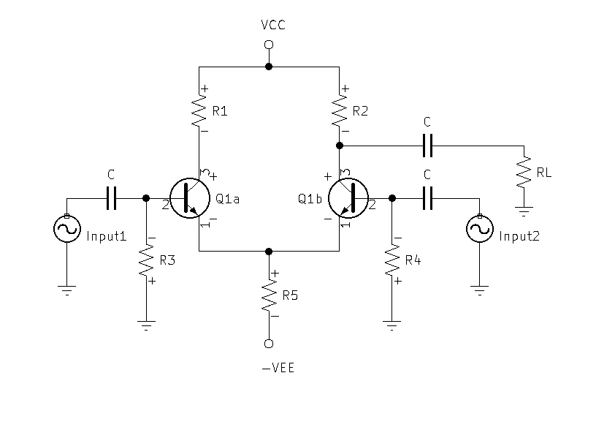

**DC Biasing**:

* R1 = R2 = RL
* R3 = R4
* VCC = $VEE(-1)$
* C value $≈10uF$ depending on low frequency response needs.
${Beta}_{Q1a}={Beta}_{Q1b}$

* Optimize:

$V_{R1\&R2} = 45\%(VCC+VEE)$

${VCE}_{Q1a\&Q1b}=45\%(VCC+VEE)$

$V_{R5} = 10\%(VCC+VEE)$

$IR5=2IE$

$V_{R3\&R4}=VEE-VR5-VBE$

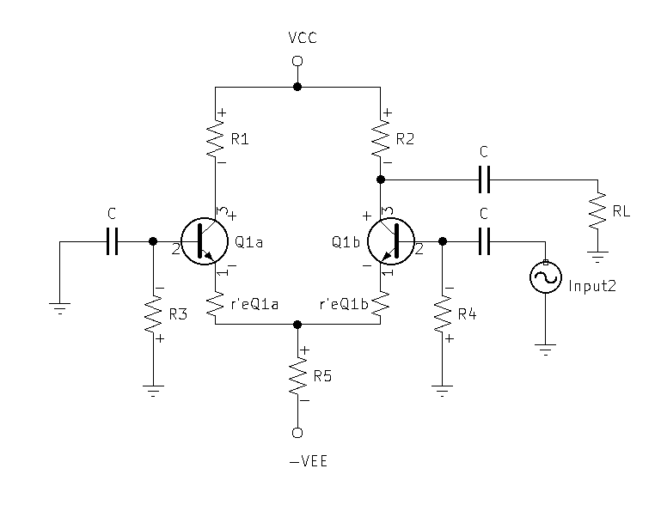**Gain Calculations:**

* Single-Ended Inverting Gain:

${∆v}_{CE}=\frac{Vout}{Vin}$

${∆v}_{CE}=\frac{IC(R2//RL)}{IB((r^{'}eQ1a//R5)+r^{'}eQ1b)(B+1)}$

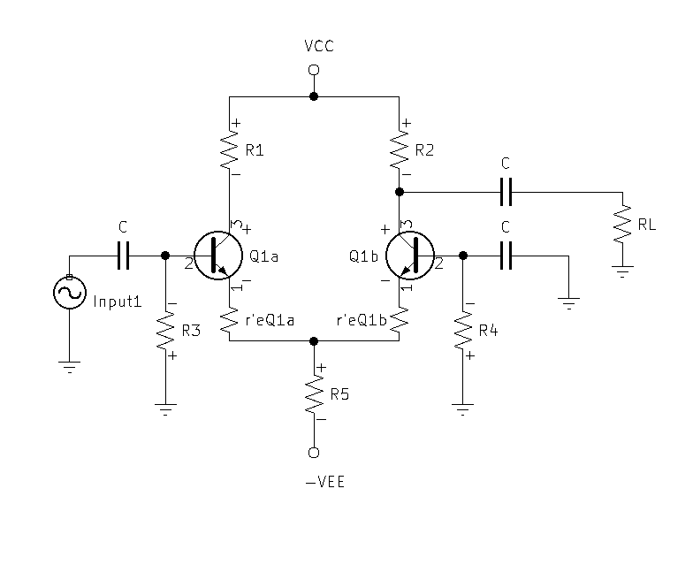

* Single-Ended Non-Inverting Gain:
${∆v}_{CC}=\frac{Vout}{Vin}$

${∆v}_{CC}=\frac{IE(r^{'}eQ1b//R5)}{IB({(r}^{'}eQ1b//R5)+r^{'}eQ1a)(B+1)}$

${∆v}_{CC}≈0.5$

${∆v}_{CB}=\frac{Vout}{Vin}$

${∆v}_{CB}=\frac{IC(R2//RL)}{IE(r^{'}eQ1b)}$

${∆v}_{CB}≈2×{∆v}_{CE}$

${∆v}_{CCCB}={∆v}_{CC}×{∆v}_{CB}$

* Double-Ended Gains:

${∆v}_{Common mode}={∆v}_{CCCB}-|{∆v}_{CE}|$

${∆v}_{Common mode}≈0$

${∆v}_{differential mode}={∆v}_{CCCB}+|{∆v}_{CE}|$

${∆v}_{differential mode}≈2×{∆v}_{CE}$

$Common Mode Rejection Ratio:$

$CMRR=20Log(\frac{{∆v}_{Common mode}}{{∆v}_{differential mode}})$